**Assignment HTML**

1. Create another .html file that contains a heading and a couple of paragraphs. You could name this new file another_page.html, and you should place it into the same folder where your first .html is. After you have created the new .html page, add a link to the first page so that the browser will load another_page.html when you click the text Go to the other page. in the first page. You need to use the <a> and </a> tags in this exercise. Inside the tag <a> you need to use a href attribute that specifies which page will be loaded when the link is clicked.
2. Create a Resume using HTML Tags.
3. List Assignment :
4. Introduction to Programming
   1. Variables and Data Types
   2. Control Structures
   3. Functions
5. Data Structures and Algorithms
   1. Arrays and Lists
   2. Stacks and Queues
   3. Trees and Graphs
6. Database Management Systems
   1. Relational Database Concepts
   2. SQL Queries
   3. Normalization
7. Table Assignment :

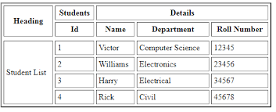

1. Create a Doctor Appointment Form using HTML and CSS.



**Assignment CSS**